Wetland Hydrogeomorphic (HGM) Classes and Key for Minnesota

Wetland hydrogeomorphic (HGM) classification incorporates geomorphic setting, predominant water source, and hydrodynamics into a single system to provide a framework to assess wetland functions.

The following dichotomous key can be used to determine the HGM class of a wetland area. The key was adapted from the original HGM class definitions (Smith et al. 1995) and the United States Environmental Protection Agency National Wetland Condition Assessment key (2021). This key incorporates the following wetland features that were not specifically addressed in previous keys:
- Floating mat wetlands
- Wetlands within depressional basins where vertical peat accumulation is a predominant process (i.e., Organic Soil Flat)
- Topographically flat wetlands where groundwater is the predominant source (i.e., Slope – Groundwater)
- Topographically sloped wetlands where surface water is the predominant source (i.e., Slope – Surface Water)
- Saturated soil wetland that is contiguous with streams or lakes that are not floating and are largely above bi-directional flow influence from the stream or lake (i.e., flat or slope)
The HGM classes (all capitals) and sub-classes recognized here are as follows:
- RIVERINE – Upper Perennial
- RIVERINE – Lower Perennial
- LACUSTRINE FRINGE
- DEPRESSIONAL
- DEPRESSIONAL – Floodplain
- ORGANIC SOIL FLAT
- MINERAL SOIL FLAT
- SLOPE – Groundwater
- SLOPE – Surface Water

Dichotomous Key to the Hydrogeomorphic (HGM) Classes (water regimes defined below)
- Wetland is associated with a perennially flowing stream, floodplain, OR fringing a lake or reservoir… 2
- Wetland is associated with a perennially flowing stream or floodplain. 3
- Stream is designated 1st or 2nd order in the National Hydrography Dataset (NHD)… 4
- Regular overbank flooding occurs (e.g., there is an apparent change in water regime or vegetation close to the channel compared to broader contiguous wetland)….. RIVERINE – Upper Perennial
- Regular overbank flooding typically does not occur (e.g., no apparent change in water regime or vegetation in broader contiguous wetland). 7
- Stream is designated 3rd order or higher in NHD and regular overbank flooding occurs……… 5
- Wetland lacks a closed topographic contour to retain water following overbank flooding conditions (i.e., the wetland is the floodplain) RIVERINE – Lower Perennial
- Wetland has a closed topographic contour such that floodwater is retained relative to the adjacent floodplain wetland following overbank flooding conditions (i.e., a depression within a broader floodplain) DEPRESSIONAL – Floodplain
- Wetland is fringing a lake or reservoir (e.g., named lake in Public Water Inventory, has Limnetic NWI subsystem polygons in the continuous basin) 6
- Lake water elevation maintains wetland hydrology – surface water flows bi-directionally between the wetland and lake (wetlands with A, C, or F water regimes) AND/OR the wetland consists of a floating mat (with a C or D water regimes). LACUSTRINE FRINGE
- Wetland elevation above typical high water lake elevation and not consisting of a floating mat (typically wetlands with a D water regime that are not floating) 7
- Wetland is not associated with a perennially flowing stream channel, floodplain, or fringing a designated lake…………………………………………………………………………………………………………………………………………………7
- Wetland is within a closed elevation contour that allows for water accumulation (i.e., a depressional basin, includes beaver and manmade impoundments and excavations) 8
- Wetland has a predominantly D water regime, is not floating, AND vertical accretion of peat has produced a flat surface. ORGANIC SOIL FLAT
- Wetland has any other predominant water regime or has a D water regime, consists of a floating mat, and does not have significant vertical accretion of peat. DEPRESSIONAL
- Wetland is not within a closed elevation contour. 9
- Wetland is on a topographic slope (e.g., > 1% percent slope). 10
- Groundwater is the primary water source (e.g., histic epipedon/histosol, groundwater indicator species). SLOPE – Groundwater
- Precipitation is the primary water source (e.g., groundwater indicator species not prevalent) ……………………………………………………………………………………………………SLOPE – Surface Water
- Wetland is topographically flat (e.g., < 1% slope) 11
- Wetland has predominantly mineral soil (if organic surface layer present, < 20 cm in depth) MINERAL SOIL FLAT
- Wetland has predominantly organic soil (an organic surface layer ≥ 20 cm present)……. 12
- Precipitation is the primary water source. ORGANIC SOIL FLAT
- Groundwater is the primary water source (e.g., groundwater indicator spp. present). …………………………………………………………………………………………………SLOPE – Groundwater

Water Regime Types Defined:
- Temporarily flooded (A) – Surface water is present for brief periods (from a few days to a few weeks) during the growing season, but the water table usually lies well below the ground surface for most of the season.

- Seasonally saturated (B) - The substrate is saturated at or near the surface for extended periods during the growing season, but unsaturated conditions prevail by the end of the season in most years. Surface water is typically absent but may occur for a few days after heavy rain and upland runoff.

- Seasonally flooded (C) - Surface water is present for extended periods (generally for more than a month) during the growing season but is absent by the end of the season in most years. When surface water is absent, the substrate typically remains saturated at or near the surface.
- Continuously saturated (D) - The substrate is saturated at or near the surface throughout the year in all, or most, years. Widespread surface inundation is rare, but water may be present in shallow depressions that intersect the groundwater table, particularly on a floating peat mat.
- Seasonally saturated - Flooded (E) - Surface water is present for extended periods (generally for more than a month) during the growing season but is absent by the end of the season in most years. When surface water is absent, the substrate typically remains saturated at or near the surface.
- Semi-permanently flooded (F) – Surface water persists throughout the growing season in most years. When surface water is absent, the water table is usually at or very near the land surface.
- Intermittently exposed (G) - Water covers the substrate throughout the year except in years of extreme drought.
- Permanently flooded (H) - Water covers the substrate throughout the year in all years.

HGM type examples:
The following are examples of how to interpret wetland mapping, vegetation, and water regimes to determine wetland HGM. The figures illustrate simplified NWI mapping of larger HGM type units often from multiple NWI polygons. Figure captions describe important considerations for how an HGM type for given wetland area can be interpreted using the key.

FIGURE 1. Example of Riverine-Upper Perennial with adjacent Organic Soil Flat.
The wetland immediately adjacent to the 2nd order stream consists of scrub-shrub, emergent, and forested vegetation structural classes with a continuously saturated water regime. The scrub-shrub and emergent classes immediately adjacent to the stream are dominated by a mix of willows, alder, sedges, and Canada bluejoint grass while the forested class is a mix of black ash and black spruce farther out from the stream channel. Both areas have deep organic soils. The difference in vegetation indicates occasional overbank flooding in the scrub-shrub and emergent areas, whereas the forested area is likely outside the zone of regular overbank flooding from the stream and more precipitation-driven. Given the change in water source the scrub-shrub and emergent areas would be Riverine-Upper Perennial HGM class whereas the forested area would be Organic Soil Flat HGM class.
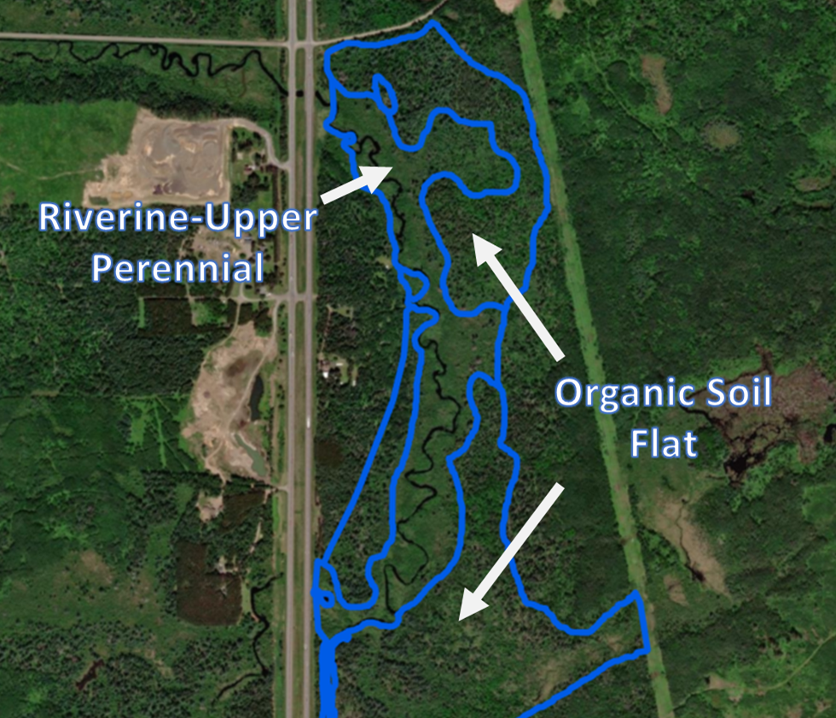

Figure 2. Example of Riverine-Lower Perennial.
The wetland adjacent to this 4th order stream is a forested vegetation structural class dominated by silver maple and elm with a temporarily flooded water regime and mineral soils. The primary water source for the wetland is overbank flooding from the stream/river. The wetland is a Riverine-Lower Perennial HGM class.
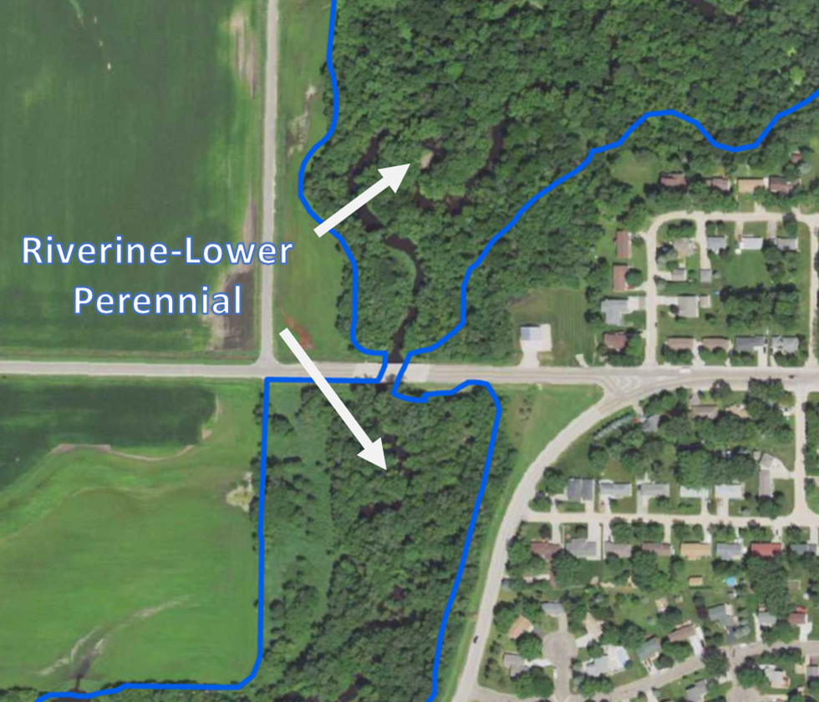

FIGURE 3. Example of Riverine-Lower Perennial with a Depressional-Floodplain basin.
The wetland occurs on a large river floodplain as a mix of forested and emergent vegetation structural classes dominated by silver maple and reed canary grass. The water regime is temporarily flooded except for a semi-permanently flooded 23-acre depression of cattails. The depression receives overbank flooding but also holds surface water much longer than the surrounding forested and emergent areas. The 23-acre basin is Depressional-Floodplain HGM class as opposed to the surrounding Riverine-Lower Perennial HGM class.
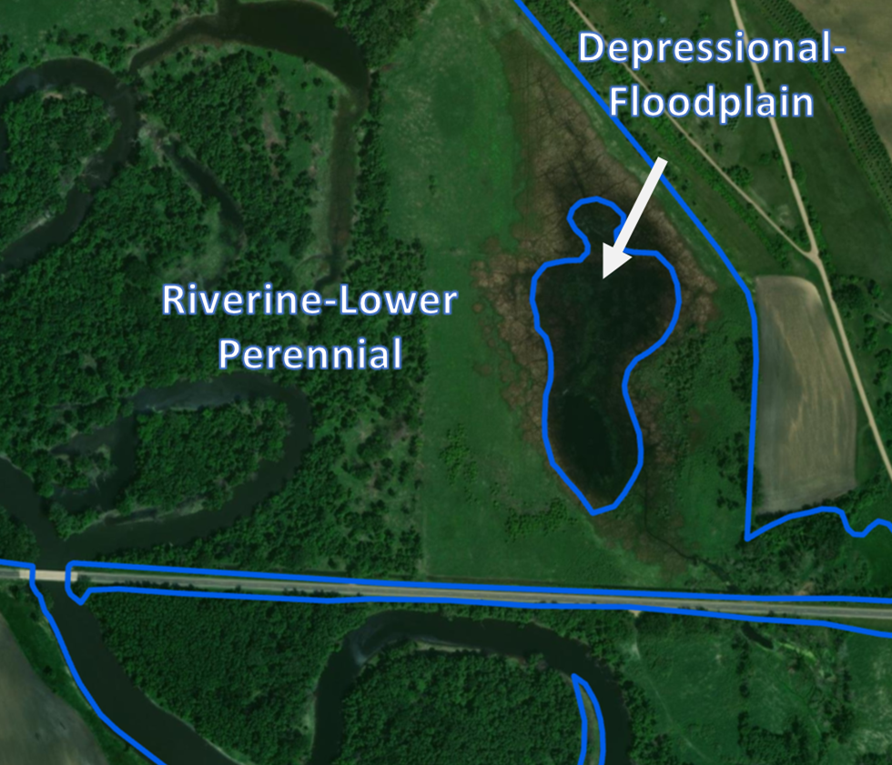

FIGURE 4. Example of Lacustrine Fringe.
A small/shallow lake has four contiguous wetlands of littoral aquatic bed vegetation structural class. The wetlands have a combination of permanently, semipermanently, seasonally, and temporarily flooded water regimes. Surface water flows both to and from the lake to the contiguous wetlands (bi-directional flow). The wetlands are Lacustrine HGM class.
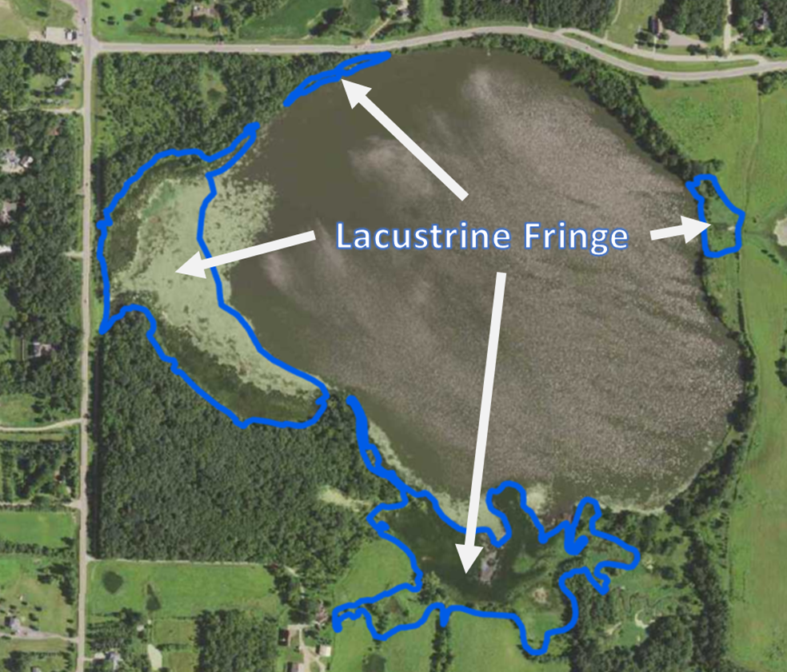

FIGURE 5. Example of Depressional.

The wetland occurs in a depressional basin and has been restored by construction of a berm with an outlet in the northwest corner where surface water exits intermittently. The wetland has permanently flooded and seasonally flooded water regimes and is Depressional HGM class.

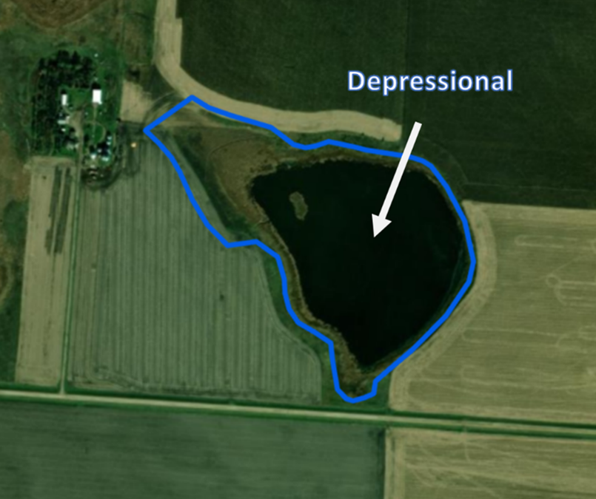

FIGURE 6. Example of Depressional.

The wetland occurs in a depressional basin where a road completes the elevation contour. The emergent wetland dominated by cattail has a seasonally flooded water regime but also includes a small permanently flooded area of unconsolidated bottom. Surface water discharges north via a culvert. The wetland is Depressional HGM class.

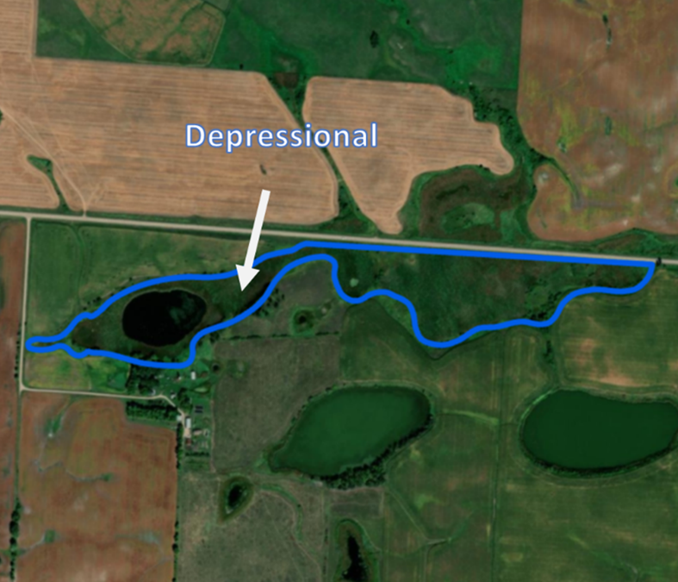

FIGURE 7. Example of Depressional & Organic Soil Flat.

This depressional wetland has been modified by beaver activity. Surface water enters the wetland from the southeast, and a beaver dam forms the western boundary. The bright green and dark signatures on the image are the open pond areas (i.e., aquatic bed vegetation structural class and permanently flooded water regime). The rest of the wetland has a seasonally flooded water regime with a floating mat of wiregrass sedge. Directly adjacent is an area of mixed emergent and scrub-shrub wetland that is not floating and has a continuously saturated water regime. Given the stark change in vegetation and water regime, this adjacent area should be considered as an Organic Soil Flat HGM class separate from the Depressional HGM class that has been modified by beaver activity.

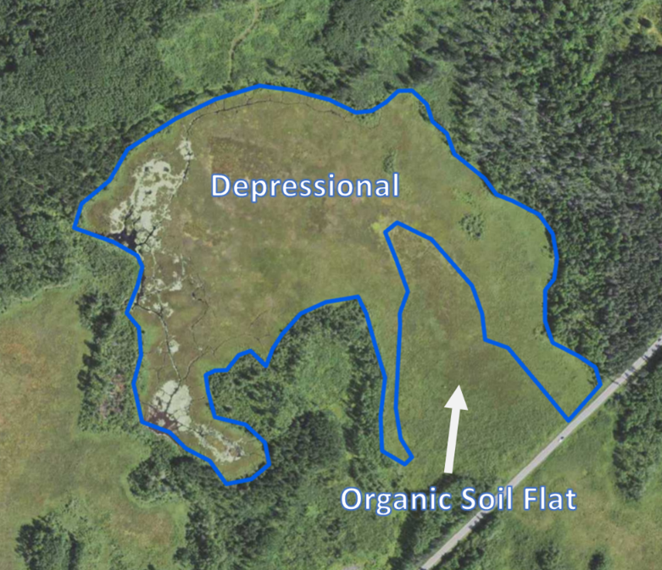

FIGURE 8. Example of Organic Soil Flat.

The wetland is part of an extensive organic soil flat consisting of forested (tamarack/black spruce), scrub-shrub (leather leaf and willow/alder), emergent (sedges) vegetation structure classes, all of which have a continuously flooded water regime. The wetland is Organic Soil Flat HGM class.

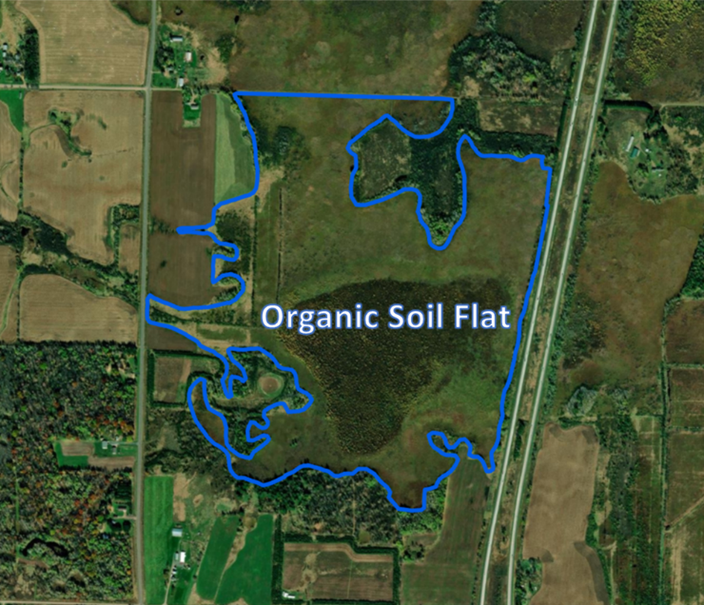

FIGURE 9. Example of Organic Soil Flat.

The wetland is a scrub-shrub vegetative structural class dominated by sphagnum moss and leatherleaf with a continuously saturated water regime and deep organic soils. Although this wetland occurs in an isolated depression, the presence of the peat-forming sphagnum moss and organic soils indicates that peat is accreting consistent with Organic Soil Flat HGM class.

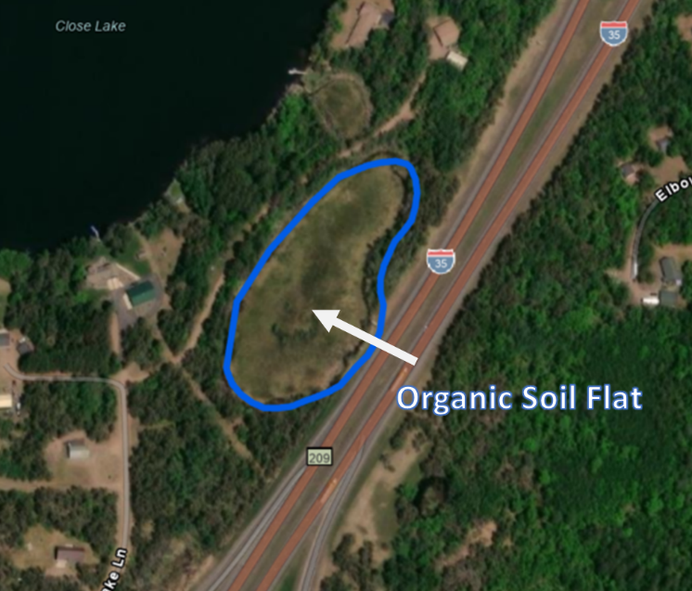

FIGURE 10. Example of Slope-Surface Water.
The wetland is forested (green and black ash-dominated) with a temporarily flooded water regime. It occurs within a narrow valley forming the headwaters for a 1st order stream. The soil texture is predominately loamy/clayey. The mineral soil, lack of groundwater species, and headwater position indicate the predominate source of wetland hydrology is from precipitation and surface water from the surrounding watershed, as opposed to groundwater discharge or overbank flooding. The wetland also slopes longitudinally, and surface water is not ultimately ponded behind an elevation contour making it a Slop-Surface Water HGM class wetland.

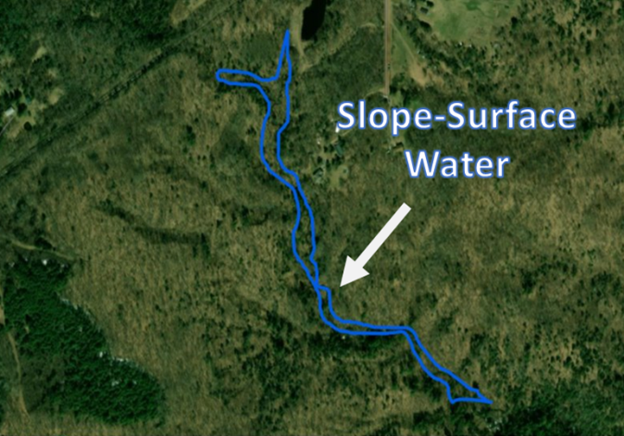
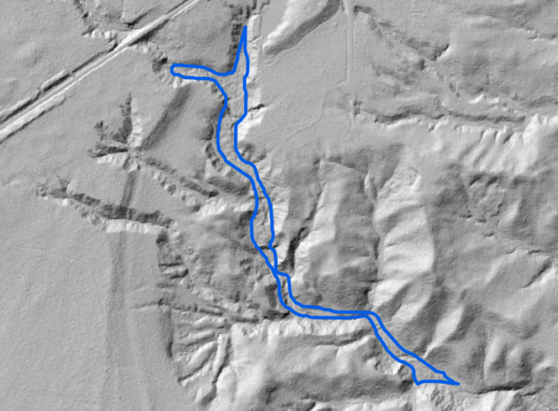

FIGURE 11. Slope-Groundwater.
The wetland is located at the toe slope of a large river valley and slopes southeast to northwest with a 19-foot elevation drop over 1,000 feet (1.7% slope) before ultimately transitioning into a forested floodplain. The wetland has an emergent vegetative structure class dominated by reed canary grass, sedges and cattails. Surface soils are muck indicating groundwater discharge. The wetland is a Depressional-Floodplain HGM class separate from the adjacent forested floodplain.

