**Alliance to Advance Climate-Smart Agriculture**

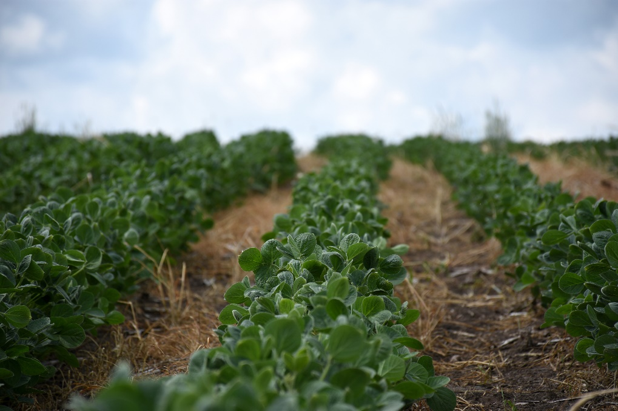**Funding Available for Minnesota Producers**

Producers in eight Minnesota counties are eligible to receive $100 per acre or animal unit for integrating climate-smart agricultural practices into their farming operations. Climate-smart practices are those that sequester carbon, reduce greenhouse gas emissions, increase soil health and improve water quality.

Participating counties include (East) Otter Tail, Fillmore, Houston, Kandiyohi, Redwood, Renville, Stevens and Wadena. SWCDs in these counties are receiving grant funding from the Minnesota Board of Water and Soil Resources (BWSR) to assist local landowners with navigating the process of adapting their operations for climate-smart practices.

*Soybeans were planted directly into oats and winter rye cover crops.*

**About the Alliance to Advance Climate-Smart Agriculture**

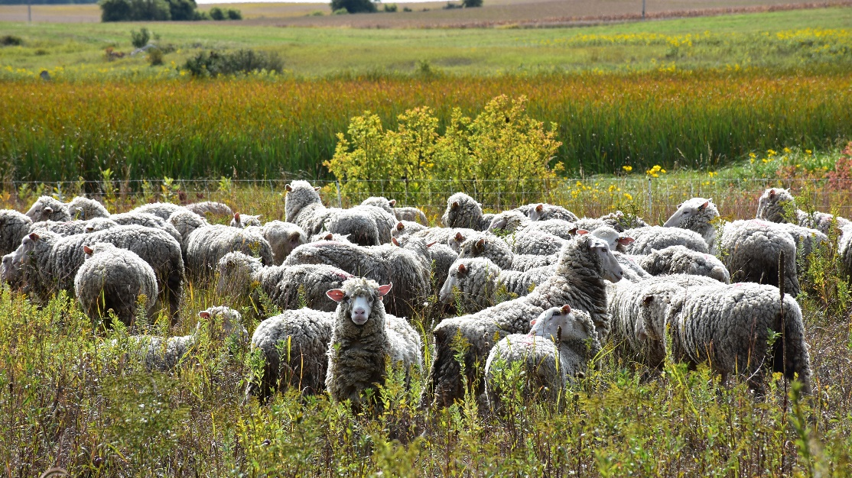Funding is available through the [Alliance to Advance Climate Smart Agriculture](https://gcc02.safelinks.protection.outlook.com/?url=https%3A%2F%2Fwww.allianceforcsa.org%2F&data=05%7C02%7Cmary.juhl%40state.mn.us%7C6bb9566fedcb40797bcb08dc5edf2ef2%7Ceb14b04624c445198f26b89c2159828c%7C0%7C0%7C638489559917513322%7CUnknown%7CTWFpbGZsb3d8eyJWIjoiMC4wLjAwMDAiLCJQIjoiV2luMzIiLCJBTiI6Ik1haWwiLCJXVCI6Mn0%3D%7C0%7C%7C%7C&sdata=jaOBT5Zh2b5yBrjmU530J4ezXh5PYvgRhZbtY1j4eZM%3D&reserved=0), a national USDA-funded pilot program led by Virginia Tech University (formerly known as the RIPE100 program) to support the adoption of climate-smart practices. During the three-year pilot program, a total of $80 million will be available to partners in Minnesota, Virginia, Arkansas and North Dakota for producer payments and program administration. BWSR is facilitating the pilot program for Minnesota, where up to $15 million is available.

The first round of producer sign-ups, from mid-July through mid-August 2024, attracted 455 applicants across the eight districts. Of this number, almost 400 were selected to participate through a random selection process developed by Virginia Tech’s researchers. A second round of sign-ups runs from January through mid-February 2025.

*Sheep graze in a prescribed grazing system. Prescribed grazing is an eligible practice under the Alliance program.*

By proving the value of climate-smart practices, this pilot program has the potential to serve as a national model. Awarded districts will have an opportunity to lead the state and the nation in implementing this one-of-a-kind pilot to compensate producers based on the multiple benefits of their stewardship practices.

**Equity focus**

Producers qualifying as Socially Disadvantaged or Limited Resource will receive an equity payment equal to 25% of the standard $100 per unit rate. A producer may only qualify for one equity payment up to 160 acres or animal units. See [www.allianceforcsa.org/producer-guide/](http://www.allianceforcsa.org/producer-guide/) for definitions of these terms.

Farmers who operate less than five acres will receive a minimum payment of $500 to help install the climate-smart practice. Operations of less than five acres operated by a socially disadvantaged or limited resource producer will receive a minimum payment of $625.

**Conservation Practices**

**Eligible practices include:**

* Cover crops;
* Residue and tillage management (no-till, reduced till);
* Nutrient management;
* Conservation crop rotation;
* Silvopasture;
* Riparian forest buffer;
* Riparian herbaceous cover;
* Pasture and hay planting;
* Tree and shrub establishment;
* Prescribed grazing.

**State and National Partners**

BWSR is working closely with the Minnesota Association of Soil and Water Conservation Districts (MASWCD) and other partners, including the Minnesota Farmers Union, the Minnesota State Cattlemen’s Association, Renewing the Countryside, the Sustainable Farming Association of Minnesota, and the Minnesota Soil Health Coalition. **National partners include the National Black Growers Council, the Sustainable Food Lab, and the National Association of Conservation Districts.**

**Contacts**

*Suzanne Rhees, Special Projects Coordinator*

[*Suzanne.rhees@state.mn.us*](mailto:Suzanne.rhees@state.mn.us)

*651-539-2586*

*Jennifer Hahn, Federal Conservation Programs Coordinator*

[*Jennifer.hahn@state.mn.us*](mailto:Jennifer.hahn@state.mn.us)

*651-396-6043*