[Grab your reader’s attention with a great quote from the document or use this space to emphasize a key point. To place this text box anywhere on the page, just drag it.]
[Grab your reader’s attention with a great quote from the document or use this space to emphasize a key point. To place this text box anywhere on the page, just drag it.]
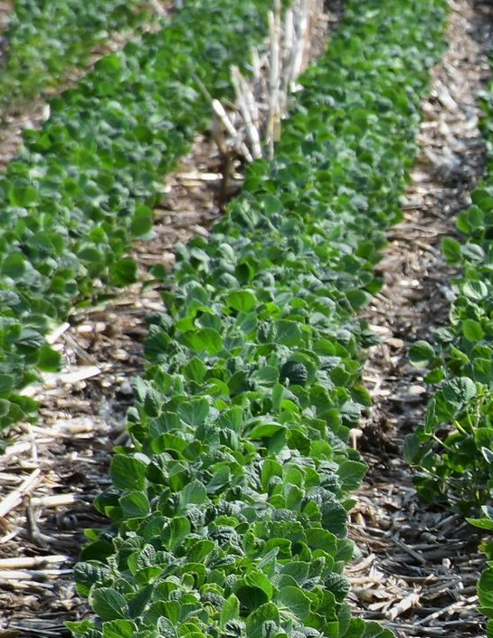


The Alliance to Advance Climate-Smart Agriculture incentivizes and rewards farmers and ranchers for adopting climate-smart agricultural practices such as cover crops, conservation crop rotation and nutrient management. Earn $100 per acre or animal unit for incorporating approved practices into your farming operation.
Event date
Event time
Location
Questions? Event contact here
EVENT TITLE

